PROJECT REPORT
TOPIC: HOSPITAL MANAGEMENT SYSTEM

SUBJECT -DATABASE MANAGEMENT SYSTEM

SUBJECT CODE- 25CAT-203

Program Name: BCA

Submitted by: Submitted to:
Name: Anureet Name: Mrs. Sunaiya
UID: 25BCA10191 Designation: Assistant professor
Section: BCA 4-B

CERTIFICATE
This is to certify that Anureet, a student of Bachelor of Computer Applications (BCA), 3rd Semester, at Chandigarh University, has successfully completed the Database Management System (DBMS) mini project entitled “Hospital Management System” during the academic session 2026–2027.
This project has been undertaken as a part of the academic curriculum for the subject Database Management System (DBMS) under the guidance and supervision of Sunaiya Mam. The project has been developed to provide practical knowledge of database management concepts and their applications in real-life situations.
The main purpose of this project is to design a simple and organized database system for managing important hospital records, including patient details, doctor information, appointments, medicines, and billing records. It demonstrates how a database can help store information systematically and retrieve it whenever required.
During the development of this project, the student has applied various DBMS concepts, including database creation, table creation, data insertion, primary keys, foreign keys, relational schemas, and SQL queries. The project also demonstrates the use of SQL commands to retrieve, update, and manage records efficiently.
The project reflects the student's understanding of the fundamental principles of a Relational Database Management System (RDBMS) and the practical importance of maintaining accurate and well-organized data. It also provides an understanding of how database systems can reduce paperwork, improve record management, and support the efficient handling of information in a hospital environment
Submitted By: Anureet
Academic Session: 2026–2027
Teacher's Signature: __________________________

ACKNOWLEDGEMENT
I would like to express my sincere gratitude to Sunaiya Mam, my DBMS project guide, for her valuable guidance, support, and encouragement throughout the preparation of my mini project entitled “Hospital Management System.” Her suggestions and guidance helped me complete this project and improve my understanding of database management concepts.
Her guidance helped me understand the practical implementation of database concepts and how SQL can be used to store, organize, update, and retrieve information efficiently. This project also gave me an opportunity to apply the theoretical knowledge gained during my BCA studies and understand the importance of databases in real-life applications.
I am thankful to Chandigarh University for providing me with the opportunity to work on this project as part of my academic curriculum. I would also like to thank my teachers and everyone who supported and encouraged me during the completion of this work.
Through this project, I gained practical knowledge of database creation, table relationships, primary keys, foreign keys, relational schemas, and SQL queries. It helped me understand how information about patients, doctors, appointments, medicines, and bills can be stored and managed systematically. I also learned how a well-designed database can reduce paperwork, improve data organization, and make information retrieval easier.
This project has been a valuable learning experience for me, as it allowed me to connect classroom learning with practical implementation. It also improved my problem-solving skills and gave me a better understanding of the role of a Database Management System in managing information accurately and efficiently.
Finally, I am grateful to everyone who directly or indirectly contributed to the successful completion of this project. Their support and encouragement have been helpful throughout this learning experience.
Anureet
BCA, 3rd Semester
Chandigarh University
Academic Session: 2026–2027

INDEX
S. No. | Contents
1. | Project Cover Page
2. | Introduction
3. | Objectives of the Hospital Management System
4. | ER Diagram
5. | Database and SQL Implementation
5.1 | Create the Database
5.2 | Create Tables
5.3 | Insert Sample Records
6. | Important SQL Queries with Output
6.1 | Display All Patients
6.2 | Display All Doctors
6.3 | Find Patients Older Than 25
6.4 | Display Appointments with Patient and Doctor Names
6.5 | Calculate Total Bill Amount
6.6 | Display Pending Bills
6.7 | Count the Number of Patients
6.8 | Update Medicine Stock
6.9 | Find the Most Expensive Medicine and display unpaid bill
7. | Relational Schema
8. | Advantages and disadvantages of the Hospital Management System
10. | Conclusion

INTRODUCTION
The Hospital Management System is a database management project designed to manage hospital information in an organized, systematic, and efficient manner. A hospital handles a large amount of information every day, including patient details, doctor information, appointment schedules, medicine records, and billing details. Managing all this information manually can be time-consuming and may lead to errors, duplication of records, and difficulties in retrieving information.
With the development of information technology, database management systems have become an important part of modern healthcare organizations. They help store, organize, update, and retrieve information whenever it is required. A well-designed database makes hospital record management easier and helps maintain consistency among related records.
The main purpose of this project is to develop a Hospital Management System using a Relational Database Management System (RDBMS). The project uses MySQL to create and manage the database and SQL (Structured Query Language) to perform different operations on the stored data.
The database consists of five main tables: PATIENT, DOCTOR, APPOINTMENT, MEDICINE, and BILL. Each table stores a particular category of information. The PATIENT table maintains patient details such as patient ID, name, age, gender, and phone number. The DOCTOR table stores doctor IDs, names, specializations, and contact details. The APPOINTMENT table records appointment dates and times and connects patients with doctors. The MEDICINE table maintains medicine names, prices, and stock quantities. The BILL table stores billing amounts and payment statuses associated with patients.
Primary keys and foreign keys are used to identify records and establish relationships between the tables. These keys help maintain data integrity and ensure that related records are connected correctly. SQL commands such as CREATE, INSERT, SELECT, UPDATE, and DELETE are used to create tables, insert records, retrieve information, modify existing data, and remove records when required.
The system can also generate useful reports through SQL queries.

Objectives of the Hospital Management System
The main objective of the Hospital Management System is to manage hospital information efficiently with the help of a database. It aims to store patient details, including their name, age, gender, and contact number, in an organized manner. It also maintains doctor information, such as their names, specializations, and phone numbers, so that records can be accessed whenever required.
Another important objective is to schedule and manage patient appointments by storing appointment dates, times, and related patient and doctor details. The system also helps maintain medicine records, including medicine names, prices, and available stock quantities. It keeps track of patient bills, payment amounts, and payment status, making it easier to identify paid and pending bills.
The system aims to reduce manual paperwork by maintaining records digitally. It uses primary keys and foreign keys to establish relationships between different tables and helps reduce duplicate records. SQL commands are used to insert, retrieve, update, and manage information in the database. This makes data searching and record management easier, faster, and more convenient.
Furthermore, the project aims to improve data accuracy, save time, and reduce the effort required to manage hospital records. It provides practical knowledge of important DBMS concepts, such as table creation, data insertion, constraints, aggregate functions, and joins. The system also provides a foundation for future improvements, such as online appointment booking, user login facilities, automatic bill generation, and report management. Overall, the project demonstrates how a relational database can help organize hospital information systematically and efficiently.

ER DIAGRAM

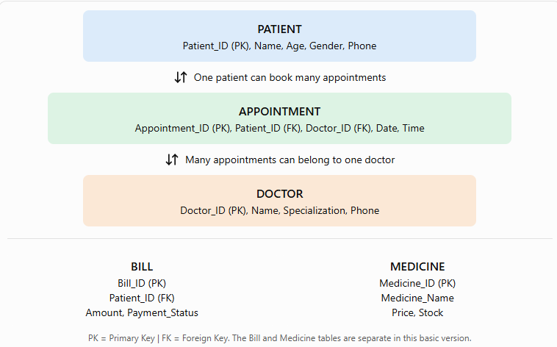
The Entity-Relationship (ER) Diagram represents the structure of the Hospital Management System database. It shows the entities, their attributes, and the relationships between different tables.
The diagram consists of five main entities: PATIENT, DOCTOR, APPOINTMENT, BILL, and MEDICINE. The PATIENT entity stores patient details such as Patient_ID, Name, Age, Gender, and Phone. The DOCTOR entity contains doctor information, including Doctor_ID, Name, Specialization, and Phone.
The APPOINTMENT entity connects patients and doctors by storing Appointment_ID, Patient_ID, Doctor_ID, Date, and Time. One patient can book multiple appointments, and one doctor can handle multiple appointments. The BILL entity maintains billing information, including Bill_ID, Patient_ID, Amount, and Payment_Status. The MEDICINE entity stores medicine details, such as Medicine_ID, Medicine_Name, Price, and Stock.
In this diagram, PK (Primary Key) uniquely identifies each record, while FK (Foreign Key) establishes a relationship between tables. The Bill and Medicine entities are separate in this basic version of the project. Overall, the ER diagram provides a clear view of the database structure and helps organize hospital records efficiently.

Database and SQL Implementation
The following SQL uses MySQL syntax. Run the commands in MySQL Workbench, phpMyAdmin, or another compatible MySQL environment.
Step 1: Create the database
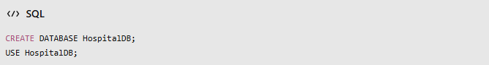
Step 2: Create tables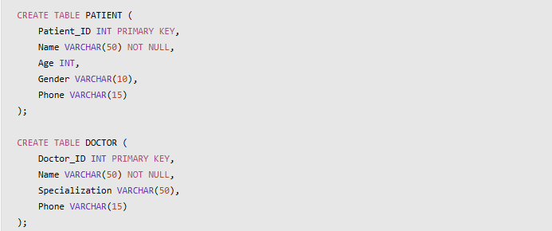
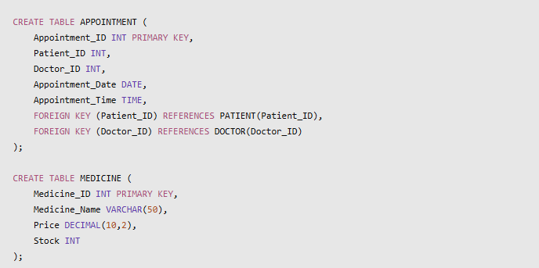
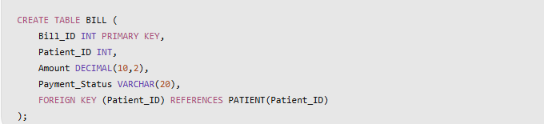
Step 3: Insert sample records
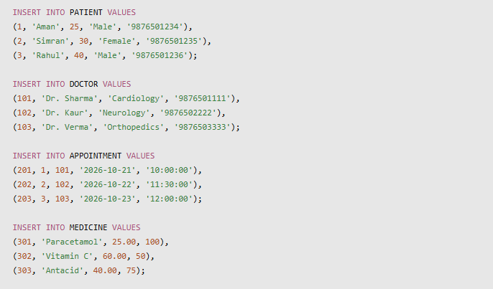
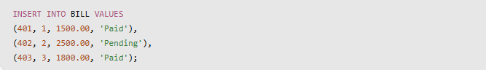

Important SQL Queries with Output
Query 1: Display all patients
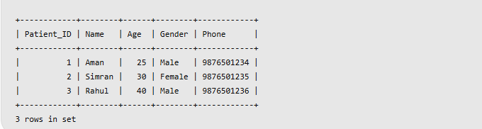
Query 2: Display All Doctors
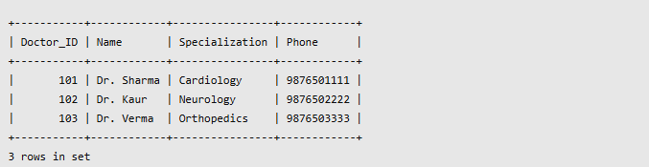
Query 3: Find Patients Older Than 25
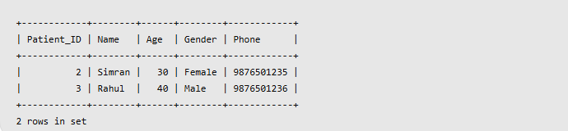

Query 4: Display Appointments with Patient and Doctor Names
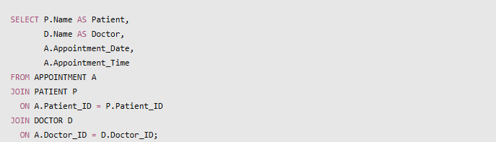
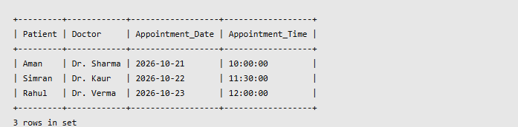
Query 5: Calculate Total Bill Amount

Query 6: Display Pending Bills
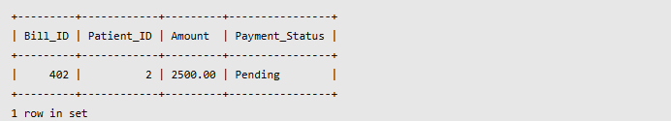

Query 7: Count the Number of Patients
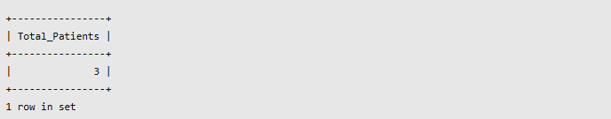
Query 8: Update Medicine Stock

Query 9: Find the Most Expensive Medicine
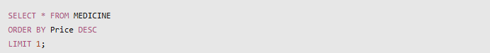
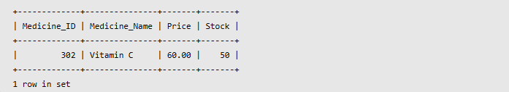
Query 10: Display Unpaid Bills with Patient Names
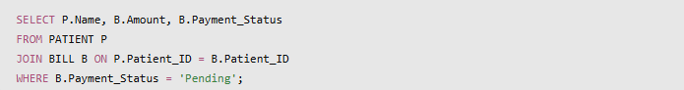
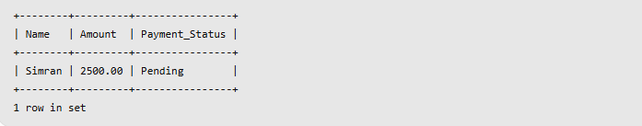

Relational Schema
The relational schema represents the structure of the Hospital Management System database in the form of tables.
Relational Schema Table
Table Name | Attributes | Primary Key (PK) | Foreign Key (FK)
PATIENT | Patient_ID, Name, Age, Gender, Phone | Patient_ID | None
DOCTOR | Doctor_ID, Name, Specialization, Phone | Doctor_ID | None
APPOINTMENT | Appointment_ID, Patient_ID, Doctor_ID, Appointment_Date, Appointment_Time | Appointment_ID | Patient_ID, Doctor_ID
MEDICINE | Medicine_ID, Medicine_Name, Price, Stock | Medicine_ID | None
BILL | Bill_ID, Patient_ID, Amount, Payment_Status | Bill_ID | Patient_ID
Explanation of the Relational Schema
1. PATIENT Table: This table stores the personal information of patients, including their unique ID, name, age, gender, and phone number. Patient_ID acts as the primary key and uniquely identifies each patient.
2. DOCTOR Table: This table maintains information about doctors, including their ID, name, specialization, and contact number. Doctor_ID is the primary key used to identify each doctor.
3. APPOINTMENT Table: This table stores appointment details, including the appointment ID, patient ID, doctor ID, date, and time. Appointment_ID is the primary key, while Patient_ID and Doctor_ID are foreign keys that connect the appointment table to the PATIENT and DOCTOR tables, respectively.
4. MEDICINE Table: This table maintains information about medicines available in the hospital. It includes Medicine_ID, Medicine_Name, Price, and Stock. Medicine_ID is the primary key that uniquely identifies each medicine.
5. BILL Table: This table stores patient billing information, including Bill_ID, Patient_ID, Amount, and Payment_Status. Bill_ID is the primary key, while Patient_ID is a foreign key referencing the PATIENT table.
Advantages of the Hospital Management System
The Hospital Management System offers several advantages by organizing hospital records in a structured database. It makes daily record management easier and helps reduce the time and effort required to handle patient, doctor, appointment, medicine, and billing information. The major advantages of this system are explained below.
1. Saves Time and Reduces Paperwork: The system stores hospital information digitally, reducing the need to maintain large numbers of paper registers. Staff can access records more quickly and manage information conveniently.
2. Easy Access to Patient Records: Patient information, such as name, age, gender, and phone number, is stored in the PATIENT table. Using SQL queries, authorized users can search and retrieve patient details whenever required.
3. Efficient Appointment Management: The APPOINTMENT table maintains appointment dates, times, and the IDs of patients and doctors. This helps organize appointments and makes it easier to identify which patient has an appointment with a particular doctor.
4. Better Doctor Information Management: The DOCTOR table stores doctors' names, specializations, and contact numbers. This information helps hospital staff find the relevant doctor details quickly.
5. Medicine Stock Management: The MEDICINE table stores medicine names, prices, and available stock quantities. The stock information can be updated when medicine quantities change, helping the hospital maintain organized medicine records.
6. Improved Billing Management: The BILL table maintains bill amounts and payment statuses. It helps identify paid and pending bills and allows the hospital to calculate the total bill amount using SQL aggregate functions such as SUM().
7. Reduced Duplicate Records: Primary keys uniquely identify records in each table. For example, every patient has a unique Patient_ID, which helps prevent two patient records from having the same primary key value.
8. Maintains Relationships Between Tables: Foreign keys connect related tables, such as PATIENT, DOCTOR, APPOINTMENT, and BILL. These relationships help maintain referential integrity and ensure that related records refer to existing entries.
9. Faster Data Retrieval: SQL commands such as SELECT, WHERE, ORDER BY, and JOIN allow users to retrieve specific information, filter records, sort data, and combine information from different tables.
10. Provides Practical DBMS Knowledge: This project demonstrates the practical use of database creation, table creation, primary keys, foreign keys, data insertion, updating, aggregate functions, and joins. It helps students understand how database concepts are applied in real-life situations.
Limitations of the Hospital Management System
Although the Hospital Management System makes record management easier, the basic version of the project has certain limitations. These limitations are related to its current features, data handling, security, and maintenance requirements.
1. Requires a Computer and Database Software: The system needs a computer and compatible database software, such as MySQL, to store and manage records. Users must have access to the database environment to execute SQL commands.
2. Depends on Correct Data Entry: The accuracy of the information depends on the data entered by the user. If incorrect patient details, appointment times, medicine prices, or bill amounts are entered, the database may contain inaccurate information.
3. Limited Security Features: The current project does not include a complete login system, role-based access control, or advanced security features. Therefore, additional security measures would be required before using it for actual hospital records.
4. No Online Appointment Booking: Patients cannot book appointments through a website or mobile application in this basic version. Appointments must be entered or managed directly through the database.
5. No Automatic Bill Generation: The system stores bill amounts and payment statuses, but it does not automatically calculate bills from consultations, medicines, or other hospital services.
6. Limited Medicine Management: The MEDICINE table stores medicine names, prices, and stock quantities. However, the current version does not automatically update stock when medicines are issued or sold.
7. Requires Regular Data Backups: Database records may be lost because of hardware failure, accidental deletion, or software problems. Regular backups are necessary to protect important information and support recovery.
8. Limited Reporting Facilities: The project supports basic SQL queries, but it does not generate advanced reports, graphical summaries, or printable patient and billing reports automatically.
9. No Complete Medical History Management: The current database does not include detailed medical histories, diagnoses, prescriptions, laboratory reports, or treatment records. These features would need additional tables and relationships.
10. Not a Complete Hospital Software Solution: This project is designed mainly for learning DBMS concepts. A real hospital system would require more advanced security, data validation, backup procedures, privacy protection, and additional features to meet operational requirements.

Conclusion
The Hospital Management System is a database project developed to demonstrate how a relational database can be used to organize and manage important hospital information. It maintains separate tables for patients, doctors, appointments, medicines, and bills, allowing different types of information to be stored systematically. This approach makes records easier to search, update, and retrieve when required.
The project uses MySQL to create the database and tables and to perform different operations through SQL commands. Queries such as SELECT, INSERT, and UPDATE help manage records, while aggregate functions such as SUM() and COUNT() provide useful information from the stored data. The use of primary keys and foreign keys establishes relationships between tables and helps maintain data consistency. The JOIN operation also allows related information, such as patient names and doctor names, to be displayed together.
This project highlights the importance of database management in reducing manual paperwork, improving record organization, and making information retrieval more convenient. It also provides practical knowledge of essential DBMS concepts, including relational schemas, entity relationships, constraints, and SQL queries. Through the development of this project, students can better understand how theoretical database concepts are applied to a practical problem.
Although the current version has limitations, such as the absence of online appointment booking, advanced security, and automatic billing, it can be improved in the future by adding these features. Additional modules for medical history, prescriptions, laboratory reports, and automatic medicine stock updates could also make the system more useful.
In conclusion, the Hospital Management System provides a basic but effective example of how database technology can support hospital record management. It strengthens practical understanding of MySQL and relational database concepts and serves as a foundation for developing a more complete hospital management application in the future.

